|  |
| --- |
| FAST National University |
|  |
|  |

**Computer Organization and Assembly Language**

**COAL Lab 10**

|  |  |
| --- | --- |
| **Student Name** | Muhammad Ali Butt |
| **Registration #** | 21L-7646 |
| **Instructor** | Hazoor Ahmad |
| **Class** | Lab-CS2A |
| **Section** | BCS-3A2 |
| **Semester** | Fall 2022 |

Fast School of Computing

FAST-NU, Lahore, Pakistan

## **Activity 1**

## **Assembly Language Code:**

[org 0x0100]

jmp start

msg1: db 'Hi! I am Ali.', 0

msg2: db 'I am Hopeful.', 0

msg3: db 'I Study at FAST.', 0

msg4: db 'My Roll No is 21L-7646.', 0

clrscr:

push ax

push es

push di

push cx

mov ax, 0xb800

mov es, ax

mov di, 0

mov cx, 2000

mov ax, 0x0720

cld

rep stosw

pop cx

pop di

pop es

pop ax

ret

getStringLength: ;Starting address of the string passed as parameter

push bp

mov bp, sp

push ax

push es

push di

push cx

mov cx, 0xFFFF

mov ax, ds

mov es, ax

mov ax, 0

mov di, [bp+4]

cld

repne scasb

mov ax, 0xFFFF

sub ax, cx

dec ax

mov [bp+6], ax

pop cx

pop di

pop es

pop ax

pop bp

ret 2

printstr: ;Receives the starting address of the message, x-position, y-position and the attribute in the form of a word.

push bp

mov bp, sp

push es

push ax

push cx

push si

push di

sub sp, 2

push word [bp+10]

call getStringLength

pop ax

cmp ax, 0

jz exit

mov cx, ax

mov ax, 0xb800

mov es, ax

mov al, 80

mul byte [bp+6]

add ax, [bp+8]

shl ax, 1

mov di, ax

mov si, [bp+10]

mov ah, [bp+4]

cld

printstrl1:

lodsb

stosw

loop printstrl1

exit:

pop di

pop si

pop cx

pop ax

pop es

pop bp

ret 8

start:

call clrscr

mov ah, 0x1

int 0x21

push word msg1

push word 20

push word 12

push word 0x7A

call printstr

mov ah, 0x1

int 0x21

push word msg2

push word 20

push word 13

push word 0x7A

call printstr

mov ah, 0x1

int 0x21

push word msg3

push word 20

push word 14

push word 0x7A

call printstr

mov ah, 0x1

int 0x21

push word msg4

push word 20

push word 15

push word 0x7A

call printstr

mov ah, 0x1

int 0x21

mov ax, 0x4c00

int 0x21

## **Screenshots:**

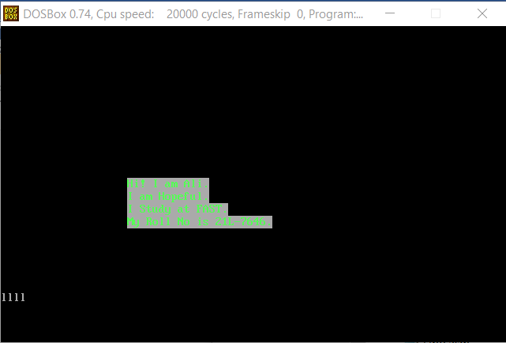

## **Activity 2**

## **Assembly Language Code:**

[org 0x0100]

jmp code

w: dw 70 ; width offset

x: dw 50 ; starting x coordinate of line

y: dw 100 ; starting y coordinate of line

c: dw 60 ; color

code:

mov ah, 0

mov al, 13h

int 10h

; draw diagonal 11:

mov bx, [x]

add bx, [w]

mov cx, [x]

mov dx, [y]

mov al, [c]

u1:

mov ah, 0Ch ; put pixel

int 10h

inc dx

inc cx

cmp cx, bx

jbe u1

add bx, [w]

u2:

mov ah, 0Ch ; put pixel

int 10h

dec dx

inc cx

cmp cx, bx

jbe u2

sub bx, [w]

u3:

mov ah, 0Ch ; put pixel

int 10h

dec dx

dec cx

cmp cx, bx

jae u3

sub bx, [w]

u4:

mov ah, 0Ch ; put pixel

int 10h

inc dx

dec cx

cmp cx, bx

jae u4

;wait for keypress

mov ah,00

int 16h

mov ax, 0x4c00

int 21h

## **Screenshots:**

